**Pool table game**

**Interactive Media Development CA2**

Samir Kahvedzic X00110033

# **Contents Page**

Technical Architecture

Contents Page 1

1. Introduction 2

1. Game features 3

2. References 4

# **Contents Page**

Introduction

Pool is a type of table top billiards sport, usually played on a six pocket tables which can be 7, 8, or 9-foot in length. The game consists of a table, a white and black ball, and a set of billiard balls that need to be hit into the pockets of the table. Eight-ball is the most widely played variety, whist 9-ball is the most common amongst professionals. It is generally played with a cue stick which is used to strike the white billiard ball, against the other billiard balls.

The table is usually cloth-covered and the surrounding of the table is covered by rubber cushions.

Game feature

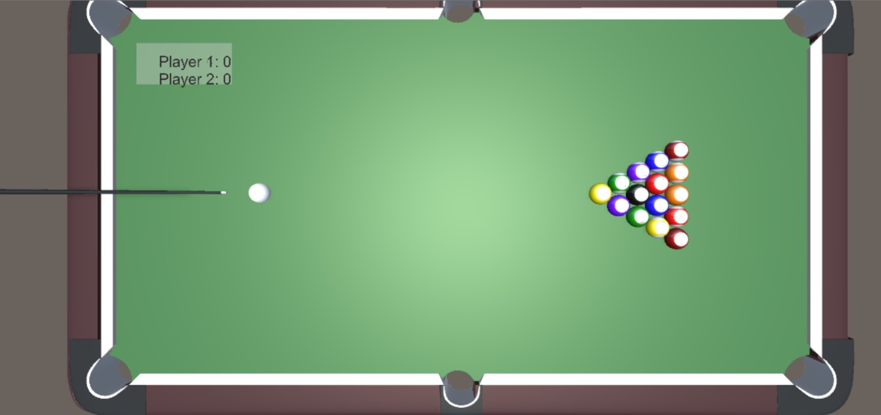

The final game consists of a

* A cue stick
* White ball
* Black ball
* 2 groups of billiard balls
* A pool table with cushions and pockets
* A score panel

The cue stick can be moved with the A and D keys, to vary the direction, whilst the power of the cue stick can be chosen with a mouse click. The billiard balls collide when they hit off of each other, and bounce off the cushions of the table.

Players take turns, and when a certain ball falls into a pocket, the relative score increases. If a black or white ball in pocketed before a game is at its end, the balls will reset to their original position.

Lighting is positioned above the table, with a single top down camera to display the entire table.

**Challenges**

One of the main challenges with creating a realistic game, is creating the physics and making it perform in a realistic way. This was attempted by adding bounce to the cushions and balls and adding drag where necessary.

References

Content: General game design

Rehm, Fabio Rehm. "Fgrehm/Pucrs-Unity3d-Pool". *GitHub*. N.p., 2015. Web. 21 Apr. 2017.

URL: <https://github.com/fgrehm/pucrs-unity3d-pool>

Content: Billiard balls assets

"Asset Store". Assetstore.unity3d.com. N.p., 2017. Web. 1 May 2017.

URL: <https://www.assetstore.unity3d.com/en/#!/content/6353>

Content: Pool Table asset

Sourced from Gavin Hickey